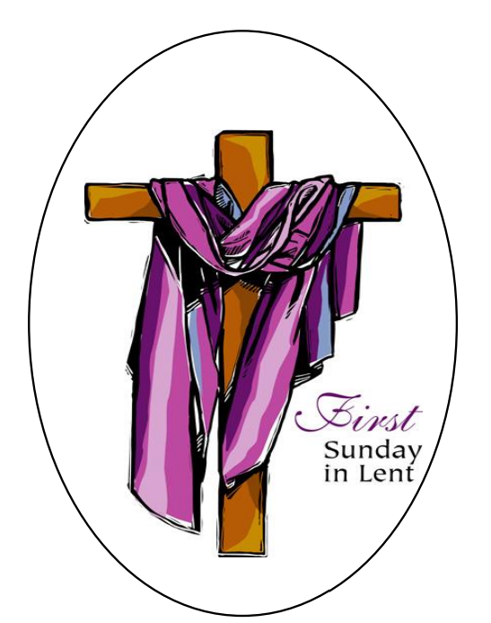

Lake Toxaway United Methodist Church
February 18 ^{th}, 2024

Lake Toxaway United Methodist Church
Community Worship Service
First Sunday in Lent, February 18th

9:30 A.M. Livestream is available on the LTUMC YouTube channel: https://www.youtube.com/channel/UCgtuJe20i8DN7S_Cfg1sWCg
RINGING OF THE BELL – Please observe silence as we prepare for the service.
PRELUDE
Wondrous Love arr. John Carter
CALL TO WORSHIP (Please stand as you are able)
Lenten travelers, when you feel the security of God’s love, affirmation of God’s call, and covered in God’s grace…
God comes near.
When you feel deserted and alone, starving and parched for a caring hand or an encouraging word, troubled and uncertain as the ground under you shifts like sand…
God comes near.
When you feel emboldened to act, inspired to speak, energized to live as bearers of the good news that the Kingdom of God is here…
God comes near.
In all seasons of our lives, God comes near to us and does not forsake us.
We gather to come near to God whose ever-present love remains near no matter where our journey takes us. Amen.
HYMN #181
Ye Servants of God
Located in the back of the bulletin - (Printed w/ permission)
Opening Prayer (Please be seated)
Lord and Shepherd of our journeys in the desert, we come to you during this Lenten season as servants of Jesus Christ. We remember how you liberated Moses and the Israelites; we remember also how you liberated the prophet Elijah in his journey to escape from a corrupt king.
Now, in our Lenten journey, we implore your direction, your patience, and your spiritual support. As you sent your angels to care for the Israelites, to the prophet Elijah in his journey, and to Jesus during his forty days in the desert, send them also to us in our earthly journeys. We ask in the name of Jesus Christ. Amen.

SCRIPTURE READINGS
Genesis 9:8-17
9:8 | Then God said to Noah and to his sons with him,
9:9 | "As for me, I am establishing my covenant with you and your descendants after you,
9:10 | and with every living creature that is with you, the birds, the domestic animals, and every animal of the earth with you, as many as came out of the ark.
9:11 | I establish my covenant with you, that never again shall all flesh be cut off by the waters of a flood, and never again shall there be a flood to destroy the earth."
9:12 | God said, "This is the sign of the covenant that I make between me and you and every living creature that is with you, for all future generations:
9:13 | I have set my bow in the clouds, and it shall be a sign of the covenant between me and the earth.
9:14 | When I bring clouds over the earth and the bow is seen in the clouds,
9:15 | I will remember my covenant that is between me and you and every living creature of all flesh; and the waters shall never again become a flood to destroy all flesh.
9:16 | When the bow is in the clouds, I will see it and remember the everlasting covenant between God and every living creature of all flesh that is on the earth."
9:17 | God said to Noah, "This is the sign of the covenant that I have established between me and all flesh that is on the earth."
Psalm 25:1-10 (Psalter Lesson)
25:1 | To you, O LORD, I lift up my soul.
25:2 | O my God, in you I trust; do not let me be put to shame; do not let my enemies exult over me.
25:3 | Do not let those who wait for you be put to shame; let them be ashamed who are wantonly treacherous.
25:4 | Make me to know your ways, O LORD; teach me your paths.
25:5 | Lead me in your truth, and teach me, for you are the God of my salvation; for you I wait all day long.
25:6 | Be mindful of your mercy, O LORD, and of your steadfast love, for they have been from of old.
25:7 | Do not remember the sins of my youth or my transgressions; according to your steadfast love remember me, for your goodness' sake, O LORD!
25:8 | Good and upright is the LORD; therefore He instructs sinners in the way.
25:9 | He leads the humble in what is right, and teaches the humble His way.
25:10 | All the paths of the LORD are steadfast love and faithfulness, for those who keep his covenant and His decrees.

1 Peter 3:18-22 (Epistle Reading)
3:18 | For Christ also suffered for sins once for all, the righteous for the unrighteous, in order to bring you to God. He was put to death in the flesh, but made alive in the spirit,
3:19 | in which also he went and made a proclamation to the spirits in prison
3:20 | who in former times did not obey, when God waited patiently in the days of Noah, during the building of the ark, in which a few, that is, eight persons, were saved through water.
3:21 | And baptism, which this prefigured, now saves you--not as a removal of dirt from the body, but as an appeal to God for a good conscience, through the resurrection of Jesus Christ,
3:22 | who has gone into heaven and is at the right hand of God, with angels, authorities, and powers made subject to him.
Mark 1:9-15 (Please stand for the Gospel)
1:9 | In those days Jesus came from Nazareth of Galilee and was baptized by John in the Jordan.
1:10 | And just as he was coming up out of the water, he saw the heavens torn apart and the Spirit descending like a dove on him.
1:11 | And a voice came from heaven, "You are my Son, the Beloved; with you I am well pleased."
1:12 | And the Spirit immediately drove him out into the wilderness.
1:13 | He was in the wilderness forty days, tempted by Satan; and he was with the wild beasts; and the angels waited on him.
1:14 | Now after John was arrested, Jesus came to Galilee, proclaiming the good news of God,
1:15 | and saying, "The time is fulfilled, and the kingdom of God has come near; repent, and believe in the good news."
L: This is the word of the Lord for the people of Christ.
P: Thanks be to God.

PRAYER OF CONFESSION (Please be seated)
Let us confess our sins against God and our neighbor.
(Let us offer our silent confessions.)
We have lists of things to do, for all the areas of our lives. Our lives are so time bound and duty bound that we feel imprisoned in them. Now we are challenged by Christ to take a journey of discipleship. We don't feel ready for this journey. We need more time. And we complain and cry about how much we have to do. Forgive us, Lord, when we place so many "duties" in the path to serving you. Reset our priorities so that we will be ready to commit our lives in your service. Lord, help us to be ready when you call us. Help us to courageously answer the summons you bring. Let us place our trust in you in all things. AMEN.

WORDS OF ASSURANCE
God is good.
All the time.
And all the time,
God is good.
Trust this truth and receive God’s gifts of mercy and love.
In the name of Jesus Christ, we are forgiven. Thanks be to God! Amen.
HOMILY
STATEMENT OF FAITH #880 (The Nicene Creed) (Please stand as you are able)
We believe in one God,
the Father, the Almighty, maker of heaven and earth,
of all that is seen and unseen.

We believe in one Lord, Jesus Christ, the only Son of God,
eternally begotten of the Father, God from God, Light from Light,
true God from true God, begotten, not made,
of one Being with the Father.
Through him all things were made.
For us and for our salvation he came down from heaven:
by the power of the Holy Spirit, he became incarnate from the Virgin Mary,
and was made man.

For our sake he was crucified under Pontius Pilate;
he suffered death and was buried.
On the third day he rose again in accordance with the Scriptures;
he ascended into heaven and is seated at the right hand of the Father.
He will come again in glory to judge the living and the dead,
and his kingdom will have no end.

We believe in the Holy Spirit, the Lord, the giver of life,
who proceeds from the Father and the Son.
With the Father and the Son, he is worshiped and glorified.
He has spoken through the Prophets.

We believe in one holy catholic and apostolic Church.
We acknowledge one baptism for the forgiveness of sins.
We look for the resurrection of the dead,
and the life of the world to come. Amen.

GLORIA PATRI (UMH #70)
Glory be to the Father and to the Son and to the Holy Ghost; as it was in the beginning, is now, and ever shall be, world without end. Amen. Amen.
HYMN #175
Jesus, the Very Thought of Thee
Located in the back of the bulletin - (Printed w/ permission)
OFFERING
https://www.wnccumc.org/online-donations-to-churches
OFFERTORY
The Gift of Love John Carter
DOXOLOGY #95 (Please stand as you are able)
Praise God from whom all blessings flow
Praise Him, all creatures here below
Praise Him above, ye heavenly host
Praise Father, Son, and Holy Ghost
Prayer of Thanksgiving (Please continue standing)

Holy God, we bring our tithes and offerings to your altar, understanding that on the journey in Lent, we can’t avoid or detour around the wilderness. It is essential that we hear Jesus call us to repentance! Bless our gifts for your unfinished kingdom work. Remind us, as we worship here, that this redemption of our lives did not come without a price; without our own repentance, we can miss the enormity of the gift Jesus gave. Knowing we cannot earn this redemption and forgiveness, this wiping clean of our ledger, we can only hope to reflect such grace and compassion in our encounters with others. In Christ’s name, we pray. Amen.

ANNOUNCEMENTS (Please be seated)
PASTORAL PRAYER AND PRAYERS OF THE PEOPLE WITH THE LORD’S PRAYER
Our Father, who art in heaven, hallowed be thy Name, thy kingdom come, thy will be done, on earth as it is in heaven. Give us this day our daily bread. And forgive us our trespasses, as we forgive those who trespass against us. And lead us not into temptation but deliver us from evil. For thine is the kingdom, and the power, and the glory, forever. Amen.

CLOSING HYMN #170 (Please stand as you are able)
O How I Love Jesus
Located in the back of the bulletin - (printed w/permission)
BENEDICTION
POSTLUDE (Please be seated)
Trumpet Voluntary Gordon Young

Announcements
Flowers on the Altar
The flowers on the altar are given by the Holimons and Markerts to the Glory of God.
Memorial Service for Jerry Kline
Jerry Kline’s memorial service will be Saturday, March 2nd at 2:00 PM.
Construction Update
The sheetrock was delivered early this week and will be installed next week. The insulation has been installed along with some electrical work. More work has been done to the breezeway roof. The old bathroom is fully functional and accessible from the new main entrance. It is the first door on the right from the main entrance.
PRAYER CONCERNS OF THE COMMUNITY
Please pray for those who have long-term illness, health concerns and special intentions. We pray for Arlene Hendrix, Andy Harvill, the Butz family, Don Guffey and Steve,
Joe Haraschak’s brother. Please also pray for Sherry Minnich’s sister, Leigh Ashman who has kidney cancer and is having surgery in late April. We also pray for Leslie Brown who has cancer and biopsies this Wednesday, 2/21 in Atlanta. Tom Cook and Patricia Simmons have asked for prayers for Sydney Sackman, their granddaughter. She is facing a challenging situation, and prayers of wisdom and confidence for her throughout the remaining weeks of February are appreciated.
Please pray for those having or had a surgery and their recovery.
Our heartfelt prayers for all who have experienced the recent passing of a loved one. Please pray for Barbara Kline as Jerry Kline passed away on Saturday, 2/10/24.
Please continue to pray for our student scholars, our local students, teachers and staff.
Staff & Lay Volunteers
Pastor: Marcus Dodson: 828-553-0282, marcus61dodson@gmail.com
Organist: Charlie Steele: cwsorgan@comporium.net
Church Administrator: Saunders Grommesh, 469-569-2314, administrator@laketoxawayumc.org
Lay Leader: Paula Markert: 828-553-9434 and Scott Walter: 314-374-2969
Audio/Visual for Livestream Chair: Andy Harvill - AV Scheduler: Fred Markert: 828-553-3303
Liturgist: Tom Blackstock
Hymns are located on the next few pages and used with permission via One License #737113-A
